MCE 320 TERM PAPER REPORT

A report on simulation of an indirect instrument(N-type thermocouple) using Matlab Simulink by Adeyemo Sheriff Adetunji(Matric number:20181702)

What is a thermocouple?

device consisting of ltwo dissimilar electrical conductors forming an electrical ctrical

A thermocouple, a so known as a "thermoelectrical thermometer", is an ele

junction. A thermocouple produces a temperature-dependent voltage as a result

of the Seebeck effect,i and this voltage can be interpreted to measure temperature. Commercial thermocouples are inexpensive, interchangeable, are supplied with t

Thermocouples are w dely used as temperature sensors.

standard connectors, and can measure a wide range of temperatures. In contras

to most other methods of temperature measurement, thermocouples are self-

powered and require no external form of excitation. The main limitation with

thermocouples is accuracy; system errors of less than one degree Celsius (°C) can

be difficult to achieve.[

temperaturelmeasurement for kilns, gas turbine exhaust, diesel engines, and other businesses as the temperature sensors in thermostats, and also as flame sensors in

Thermocoup es are widely used in science and industry. Applications include

industrial processes. Thermocouples are also used in homes, offices and

safety devices for gas-powered appliances.

Applications of thermocouples

t Thermocouples are suitable for measuring over a large temperature measurement for kilns, gas turbine exhaust, machines. They are less suitable for applications where

emperature range, from −270 up to 3000 °C (for a short

time, in inert atmosphere).[20] Applications include

diesel engines, other industrial processes and fog

smaller temperature differences need to be measured

with high accuracy, for example the range 0–100 °C with

0.1 °C accuracy. For such applications thermistors, silicon thermometers are more suitable.

bandgap temperature sensors and resistance

Brief History

circuit made up of two dissimilar metals got deflected when one of the dissimilar metal junctions was a observed was later shown to be due to thermo-electric current. In practical use, the voltage generated at a

In 1821, the German physicist Thomas Johann Seebeck discovered that a magnetic needle held near

heated. At the time, Seebeck referred to this consequence as thermo-magnetism. The magnetic field he

single junction of two different types of wire is what is of interest as this can be used to measure

temperature at very high and low temperatures. The magnitude of the voltage depends on the types of

wire being used. Generally, the voltage is in lthe microvolt range and care must be taken to obtain a usable

measurement. Although very little current f ows, power can be generated by a single thermocouple

junction. Power generation using multiple thermocouples, as in a thermopile, is common.

{\displaystyle \scriptstyle T_{\mathrm {sense}}}}\scriptstyle T_\mathrm{sense}, provided that temperature

K-type thermocouple (chromel–alumel) in the standard thermocouple measurement configuration. The

measured voltage {\displaystyle \scriptstyle V \scriptstyle V can be used to calculate temperature

{\displaystyle \scriptstyle T_{\mathrm {ref} }}\scriptstyle T_\mathrm{ref} is known.

The standard configuration for thermocouple usage is shown in the figure. Briefly, the desired temperature

Tsense is obtained using three inputs—the characteristic function E(T) of the thermocouple, the measured

voltage V, and the reference junctions' temperature Tref. The solution to the equation E(Tsense) = V +

E(Tref) yields Tsense. These details are often hidden from the user since the reference junction block (with

Tref thermometer), voltmeter, and equation solver are combined into a single product

Seebeck Effect

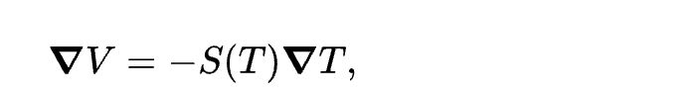The Seebeck effect refers to the development of an electromotive force across two points of an electrically conducting material when there is a temperature difference between those two points. Under open-circuit conditions where there is no internal current flow, the gradient of voltage (V) is directly proportional to the gradient in temperature. Where S(T) is a temperature-dependent material property known as the Seebeck coefficient.

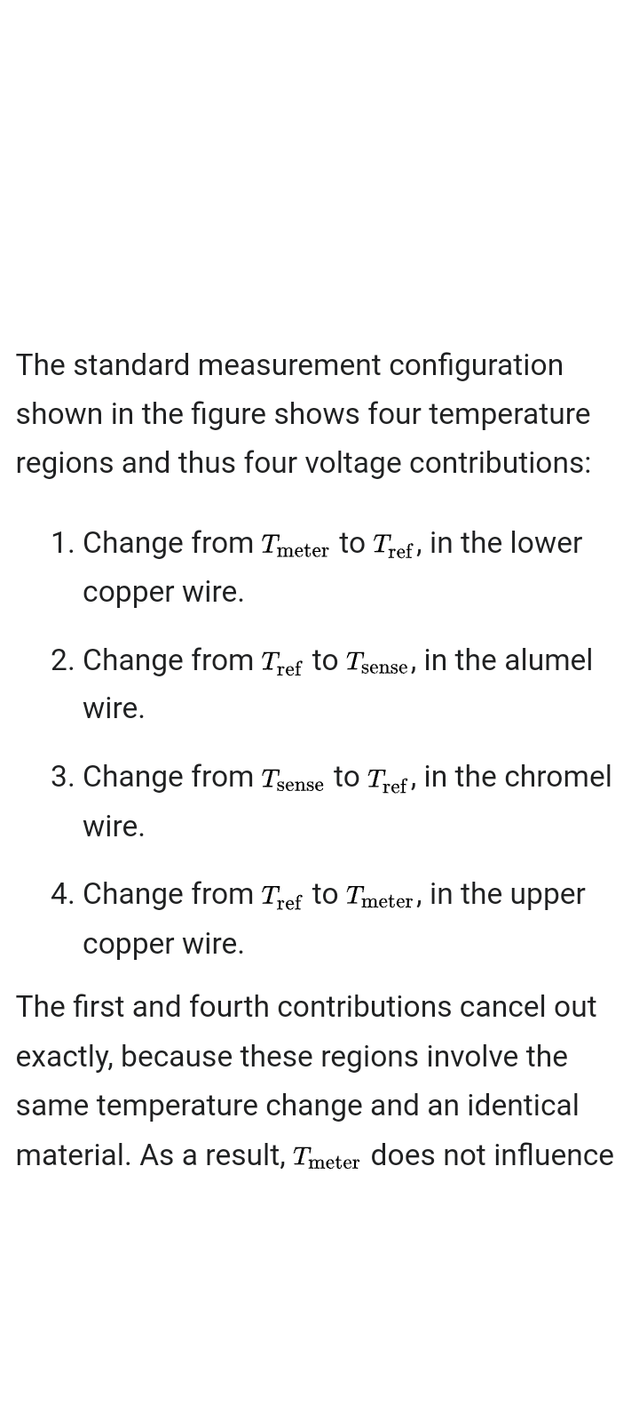

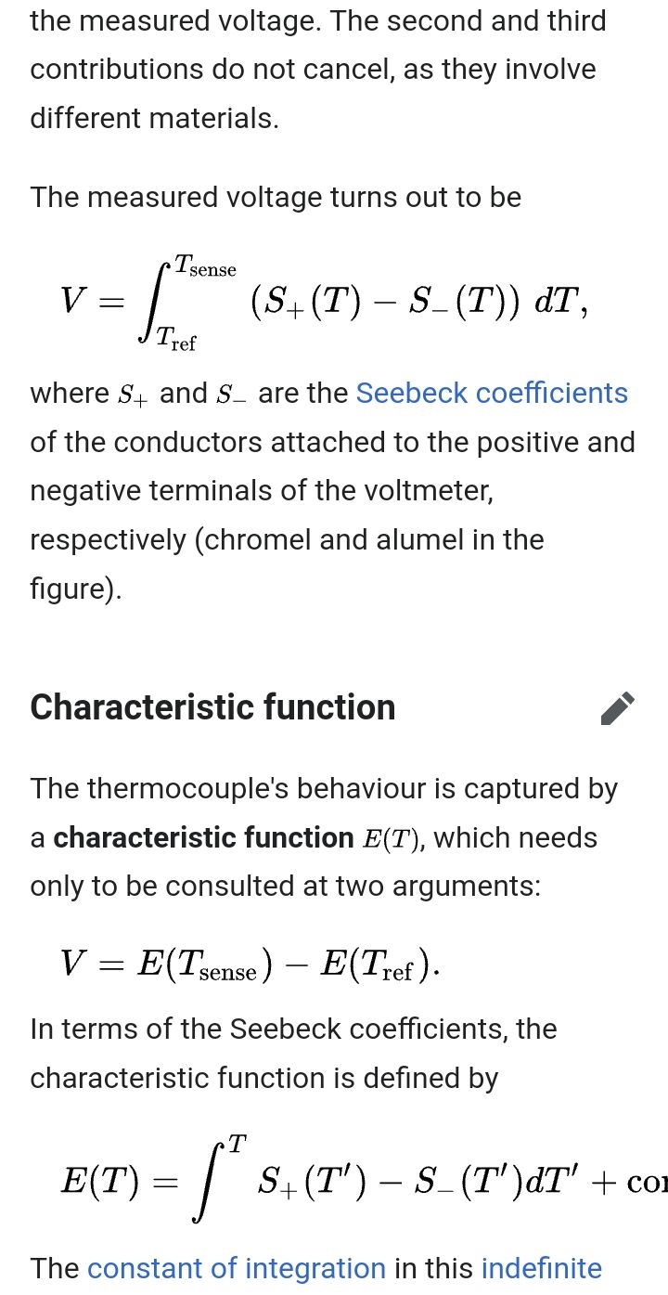

integral has no significance but is conventionally chosen such that E(0ºC)=0

TYPES OF THERMOCOUPLE

There are different types of thermocouples depending on the type of dissimilar metal used and they include:

1. Nickel-alloy thermocouples